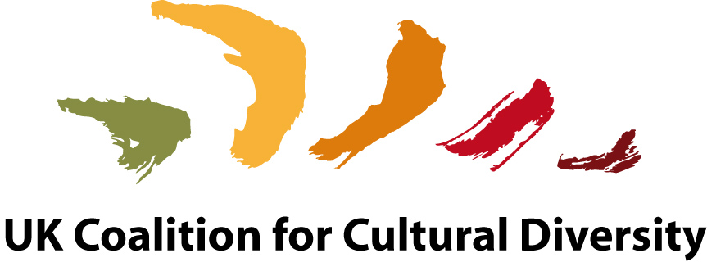

2017 ACTIONS TAKEN IN SUPPORT OF UNESCO CONVENTION

The UK Coalition for Cultural Diversity draws on over 700 cultural and creator organisations worldwide to monitor and campaign on policies which impact on pluralism of access and inclusivity in the cultural sector. Together with the International Federation it seeks to implement UNESCO’s unique Convention on Diversity of Cultural Expressions, 2005, operating at European level through the European Coalitions for Cultural Diversity (ECCD).

1. Liaising with UK National Commission for UNESCO (UKNC) on Convention agendas
The International Federation of Coalitions, of which UKCCD is a founder member, plays a leading role in the representation of civil society organisations at UNESCO’s Intergovernmental Meetings in Paris. UKCCD also monitors and advises on creator interests at national level and has informed on the UK’s second quadrennial report regarding its implementation of the Convention.

2 Advising Ministry of Culture (DCMS)
The UKCCD has held annual meetings with the Head of the International Office of the DCMS to inform on key issues of concern in relation to the Convention. In particular we have briefed on the impact of digital technologies, the concerns of the creator community about the Digital Single Market and generally about upholding the cultural exception in the mandate for the US-Europe Free Trade Agreement, TTIP.
We are also advising on the DCMS’s submission of the second quadrennial review to UNESCO.

3 Civil Society Report and Representation to UNESCO Intergovernmental Committee This year UKCCD has played a leading role in delivering the first ever civil society report to government parties on the challenges facing the creator sector in implementing the Convention and giving recommendations for change. Civil society has been invited to comment on Parties’ working documents and UKCCD is active in defending policy needed to sustain the creative industries especially in the new business models of the digital era.

4 Lobbying UK MEPS and MPs
UKCCD has lobbied UK parliamentarians on the need to ensure:
- fair remuneration for authors; artists; performers and other creators
- a high level of copyright protection
- piracy online is effectively combatted
- books, music, audio-visual work are excluded from the scope of the EU geo-blocking directive
- a 30% quota for UK/EU works is mandated in VOD catalogues
- fair taxation of tech giants

We have lobbied decision makers before crucial votes in the European Parliament.

We have co-organised events in the European Parliament to support the lobbying mentioned above.

5 Advising Labour Party on Creative Industry Strategy
UKCCD has continued to lobby the Labour Party so that cultural agendas remain central to policy review and in particular to inform on developments regarding European Union proposals for the Digital Single Market.

6 Defence of Public Service Broadcasting
UKCCD is part of a network of academics, cultural institutions and unions who monitor and support strong public service broadcasting as one of the principle guarantors of cultural diversity in the UK.

7 UK Cultural Indicators
The UKCCD is building partnerships, including the National Campaign for the Arts and Kings College, London University to establish a national set of indicators to act as benchmarks to monitor the impact of national cultural policy on diversity of cultural expressions.

8 Actions through European Coalitions for Cultural Diversity (ECCD)
Carole Tongue is President of the ECCD and Holly Aylett one of its Vice Presidents.
- Contacts were established and maintained with MEPS and members of secretariats (of political groups and committees)
- Meetings with parliamentarians on authors’/artists rights to fair remuneration for the exploitation of their work online; territoriality to protect EU film funding models; revision of the AVMS directive to secure a 30% quota in VOD catalogues for UK/EU works; revision of 2001 copyright directive to achieve a high level of copyright protection.
- Carole Tongue, President of the European Coalitions, had ongoing meetings with all key MEP players on a range of committees as discussions on all these key issues have been making their way through the European Parliament
- Meetings with cultural attaches of the EU Embassies of Member States to put forward the views of authors; artists and other creators on all the key issues mentioned above
- Participation in European Commission meetings on revision of the AVMS directive with other stakeholders to support an increase in the prominence of and investment in local AV production
- Invited speaker at the Cannes Film Festival on how video on demand regulation should ensure high levels of investment and visibility for national/EU works
- Co-organised and chaired events in the European Parliament in Autumn 2016 and July 2017 to support strong copyright and investment in local audiovisual production by video on demand operators
- Penned article with German MEP Helga Truepel calling for better regulation of the internet to better remunerate creators. Chasing publication

9 Advising Creative Industries Federation on European policy, Brexit and the digital single market

